Build websites like a civil engineer

**Designed, tested and published by RPLTechno IT Services Pvt Ltd (Now Crenitech)**

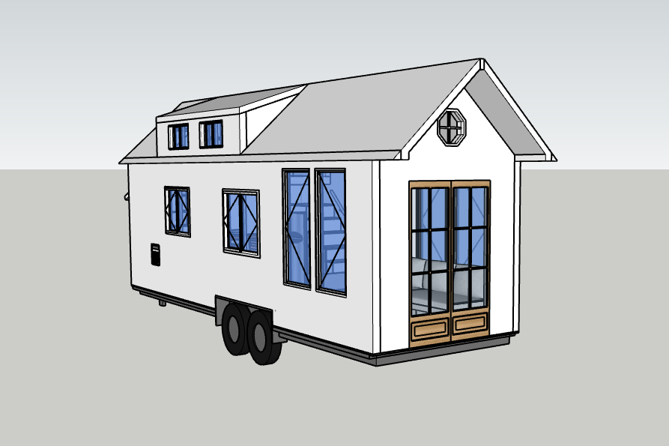

Atleast 70% percent of Front end developers visit stack overflow  to copy code snippet for their project.

To become a web developer you really need some copying skill but need to know what to copy and where to copy.

You will learn how to build websites like a civil engineer using ready-made modules like the one in picture above in this booklet. The website you going to build is function book , displaying details like Facebook without search and other functionalities.

Note: **These ready-made modules are designed, coded and compiled by team of Engineers in RPLTechno IT Services Pvt Ltd. It is completely free to copy and use with some credits if possible!**

**WEBSITE LAYOUT**

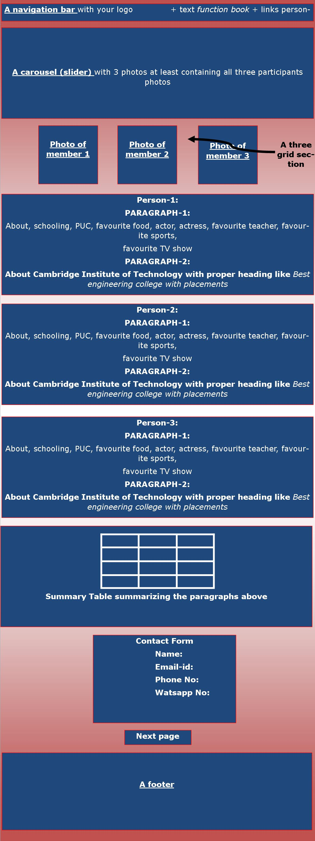

HOW TO START:

1.INSTAL THE SUBLIME TEXT SOFTWARE .

2.DOWNLOAD THE FUNCTION BOOK FOLDER :

3.THIS FOLDER WILL HAVE

**index.html** [html file where you will copy all html modules]

**style.css** [css file where you will copy all css modules]

**images**  [it is a folder having some images inside it]

4.Start copy pasting the modules ( html module in index.html and css module in style.css ) using the sublime text editor.

5.Parallely open the index.html in chrome to see your website.

NAVIGATION-BAR MODULES

1.DUMB DOCTOR

|  |  |
| --- | --- |
|  | |
| HTML | CSS |
| <!-- start navigation -->  <nav class="navbar navbar-dark navbar-expand-md fixed-top">  <div class="container-fluid">  <a class="navbar-brand" href="#"><h2><img src="images/fb.png">Function Book</h2></a>  <button class="navbar-toggler" type="button" data-toggle="collapse"  data-target="#menu">  <span class="navbar-toggler-icon"></span>  </button>  <div class="collapse navbar-collapse" id="menu">  <ul class="navbar-nav ml-auto">  <li class="nav-item">  <a class="nav-link" href="#personOne">Person-1name</a>  </li>  <li class="nav-item">  <a class="nav-link" href="#personTwo">Person-2name</a>  </li>  <li class="nav-item">  <a class="nav-link" href="#personThree">Person-3name</a>  </li>    </ul>  </div>  </div>  </nav>  <!-- end navigation --> | .navbar{    background-color:#505962;  margin-bottom: 20px;  }  .navbar-brand img{  height: 2rem;  margin-right:10px;  position:relative;  bottom:5px;  }  .navbar li{  margin-right:10px;  font-size: 20px;  } |

NAVIGATION-BAR MODULES

2.ROCKY TRANSPARENT

|  |  |
| --- | --- |
|  | |
| HTML | CSS |
| <!-- start navigation --><nav class=" navbar navbar-expand-md navbar-dark bg-dark fixed-top">  <a class="navbar-brand" href="#"><h3><img src="images/fb.png">Function Book</h3></a>  <button class="navbar-toggler" type="button" data-toggle="collapse"  data-target="#navbarResponsive">  <span class="navbar-toggler-icon"></span>  </button>    <div class="collapse navbar-collapse" id="navbarResponsive">  <ul class="navbar-nav ml-auto">  <li class="nav-item">  <a class="nav-link" href="#personOne">Person-1Name</a>  </li>  <li class="nav-item">  <a class="nav-link" href="#personTwo">Person-2Name</a>  </li>  <li class="nav-item">  <a class="nav-link" href="#personThree">Person-3Name</a>  </li>    </ul>  </div>  </nav> <!-- end navigation --> | .navbar{  text-transform: uppercase;  font-weight: 700;  font-size: .9rem;  letter-spacing: .1rem;  background: rgba(0,0,0, 0.6)!important;    }  .navbar-brand img{  height:2rem;  margin-right:10px;  position:relative;  bottom:5px;  }  .nvabar-nav li{  padding-right: .7rem;    } |

NAVIGATION-BAR MODULES

3.ANGEL WHITE

|  |  |
| --- | --- |
|  | |
| HTML | CSS |
| <!-- start navigation --><nav class="navbar navbar-expand-md navbar-light bg-light sticky-top">  <div class="container-fluid">  <a class="navbar-brand" href="#"><h3><img src="images/fb.png">Function Book</h3></a>  <button class="navbar-toggler" type="button" data-toggle="collapse"  data-target="#navbarResponsive">  <span class="navbar-toggler-icon"></span>  </button>  <div class="collapse navbar-collapse" id="navbarResponsive">  <ul class="navbar-nav ml-auto"  <li class="nav-item active">  <a class="nav-link" href="#personOne">Person-1name</a>  </li>  <li class="nav-item">  <a class="nav-link" href="#personTwo">Person-2name</a>  </li>  <li class="nav-item">  <a class="nav-link" href="#personThree">Person-3name</a>  </li>    </ul>  </div>  </div>  </nav> <!-- end navigation --> | .navbar {  padding: .8rem;  }  .navbar-nav li {  padding-right: 20px;  }  .nav-link {  font-size: 1.1em !important;  }  .navbar-brand img{  height:2rem;  margin-right:10px;  position:relative;  bottom:5px;  } |

NAVIGATION-BAR MODULES

4.RASCAL OO7

|  |  |
| --- | --- |
|  | |
| HTML | CSS |
| <!-- start navigation -->  <nav class="navbar navbar-expand-sm bg-dark navbar-dark fixed-top">  <div class="container">  <a href="index.html" class="navbar-brand"><h3><img src="images/fb.png">Function Book</h3></a>  <button class="navbar-toggler" data-toggle="collapse" data-target="#navbarCollapse">  <span class="navbar-toggler-icon"></span>  </button>  <div class="collapse navbar-collapse" id="navbarCollapse">  <ul class="navbar-nav ml-auto">  <li class="nav-item">  <a href="#personOne" class="nav-link">Person-1name</a>  </li>  <li class="nav-item">  <a href="#personTwo" class="nav-link">Person-2name</a>  </li>  <li class="nav-item">  <a href="#personThree" class="nav-link">Person-3name</a>  </li>    </ul>  </div>  </div>  </nav>  <!-- end navigation --> | .navbar{  border-bottom: #008ed6 3px solid;  opacity: 0.8;  }  .navbar-brand img{  height:2rem;  margin-right:10px;  position:relative;  bottom:5px;  } |

NAVIGATION-BAR MODULES

5.THE BOSS THEME

|  |  |
| --- | --- |
|  | |
| HTML | CSS |
| <nav class="navbar navbar-dark navbar-expand-md fixed-top">  <div class="container-fluid">  <a class="navbar-brand" href="#"><h2><img src="images/fb.png">Function Book</h2></a>  <button class="navbar-toggler" type="button" data-toggle="collapse"  data-target="#menu">  <span class="navbar-toggler-icon"></span>  </button>  <div class="collapse navbar-collapse" id="menu">  <ul class="navbar-nav ml-auto">  <li class="nav-item">  <a class="nav-link" href="#personOne">Person-1name</a>  </li>  <li class="nav-item">  <a class="nav-link" href="#personTwo">Person-2name</a>  </li>  <li class="nav-item">  <a class="nav-link" href="#personThree">Person-3name</a>  </li>    </ul>  </div>  </div>  </nav> | .navbar{    background-image:url("images/darshan.jpg");  margin-bottom: 20px;  }  .navbar-brand img{  height: 2rem;  margin-right:10px;  position:relative;  bottom:5px;  }  .navbar li{  margin-right:10px;  font-size: 20px;  } |

NAVIGATION-BAR MODULES

5.THE MASS THEME

|  |  |
| --- | --- |
|  | |
| HTML | CSS |
| <nav class="navbar navbar-dark navbar-expand-md fixed-top">  <div class="container-fluid">  <a class="navbar-brand" href="#"><h2><img src="images/fb.png">Function Book</h2></a>  <button class="navbar-toggler" type="button" data-toggle="collapse"  data-target="#menu">  <span class="navbar-toggler-icon"></span>  </button>  <div class="collapse navbar-collapse" id="menu">  <ul class="navbar-nav ml-auto">  <li class="nav-item">  <a class="nav-link" href="#personOne">Person-1name</a>  </li>  <li class="nav-item">  <a class="nav-link" href="#personTwo">Person-2name</a>  </li>  <li class="nav-item">  <a class="nav-link" href="#personThree">Person-3name</a>  </li>    </ul>  </div>  </div>  </nav> | .navbar{    background-image:url("images/prabhas.jpg");  margin-bottom: 20px;  }  .navbar-brand img{  height: 2rem;  margin-right:10px;  position:relative;  bottom:5px;  }  .navbar li{  margin-right:10px;  font-size: 20px;  } |

NAVIGATION-BAR MODULES

6.THE IPL THEME

|  |  |
| --- | --- |
|  | |
| HTML | CSS |
| <nav class="navbar navbar-dark navbar-expand-md fixed-top">  <div class="container-fluid">  <a class="navbar-brand" href="#"><h2><img src="images/fb.png">Function Book</h2></a>  <button class="navbar-toggler" type="button" data-toggle="collapse"  data-target="#menu">  <span class="navbar-toggler-icon"></span>  </button>  <div class="collapse navbar-collapse" id="menu">  <ul class="navbar-nav ml-auto">  <li class="nav-item">  <a class="nav-link" href="#personOne">Person-1name</a>  </li>  <li class="nav-item">  <a class="nav-link" href="#personTwo">Person-2name</a>  </li>  <li class="nav-item">  <a class="nav-link" href="#personThree">Person-3name</a>  </li>    </ul>  </div>  </div>  </nav> | .navbar{    background-image:url("images/IPL.jpg");  margin-bottom: 20px;  }  .navbar-brand img{  height: 2rem;  margin-right:10px;  position:relative;  bottom:5px;  }  .navbar li{  margin-right:10px;  font-size: 20px;  } |

NAVIGATION-BAR MODULES

6.THE RCB THEME

|  |  |
| --- | --- |
|  | |
| HTML | CSS |
| <nav class="navbar navbar-dark navbar-expand-md fixed-top">  <div class="container-fluid">  <a class="navbar-brand" href="#"><h2><img src="images/fb.png">Function Book</h2></a>  <button class="navbar-toggler" type="button" data-toggle="collapse"  data-target="#menu">  <span class="navbar-toggler-icon"></span>  </button>  <div class="collapse navbar-collapse" id="menu">  <ul class="navbar-nav ml-auto">  <li class="nav-item">  <a class="nav-link" href="#personOne">Person-1name</a>  </li>  <li class="nav-item">  <a class="nav-link" href="#personTwo">Person-2name</a>  </li>  <li class="nav-item">  <a class="nav-link" href="#personThree">Person-3name</a>  </li>    </ul>  </div>  </div>  </nav> | .navbar{    background-image:url("images/RCB.jpg");  margin-bottom: 20px;  }  .navbar-brand img{  height: 2rem;  margin-right:10px;  position:relative;  bottom:5px;  }  .navbar li{  margin-right:10px;  font-size: 20px;  } |

CAROUSEL MODULES

1-PLAIN WITHOUT ARROWS AND NAVIGATION

|  |  |
| --- | --- |
|  | |
| HTML | CSS |
| <!-- start carousel -->  <div id="carousel" class="carousel slide" data-ride="carousel">  <div class="carousel-inner">  <div class="carousel-item active">  <img src="images/slider-1.jpg" class="d-block w-100" alt="cambridge institute of technology best engineering college">  </div>  <div class="carousel-item">  <img src="images/slider-2.jpg" class="d-block w-100" alt="cambridge institute of technology top college in bangalore">  </div>  <div class="carousel-item">  <img src="images/slider-3.jpg" class="d-block w-100" alt="citech best engineering college">  </div>  </div>  </div>  <!-- end carousel --> | #carousel img  {  height:550px;  } |

CAROUSEL MODULES

2-WITH CONTROL ARROWS

|  |  |
| --- | --- |
|  | |
| HTML | CSS |
| <!-- start carousel -->  <div id="carouselExampleControls" class="carousel slide" data-ride="carousel">  <div class="carousel-inner">  <div class="carousel-item active">  <img src="images/slider-1.jpg" class="d-block w-100" alt="cambridge institute of technology top college in bangalore">  </div>  <div class="carousel-item">  <img src="images/slider-2.jpg" class="d-block w-100" alt="cambridge institute of technology top college in bangalore">  </div>  <div class="carousel-item">  <img src="images/slider-3.jpg" class="d-block w-100" alt="citech best engineering college">  </div>  </div>  <a class="carousel-control-prev" href="#carouselExampleControls" role="button" data-slide="prev">  <span class="carousel-control-prev-icon" aria-hidden="true"></span>  <span class="sr-only">Previous</span>  </a>  <a class="carousel-control-next" href="#carouselExampleControls" role="button" data-slide="next">  <span class="carousel-control-next-icon" aria-hidden="true"></span>  <span class="sr-only">Next</span>  </a>  </div>  <!-- end carousel --> | #carousel img  {  height:550px;  } |

CAROUSEL MODULES

3-WITH CONTROL ARROWS AND INDICATORS

|  |  |
| --- | --- |
|  | |
| HTML | CSS |
| <!-- start carousel -->  <div id="carouselExampleIndicators" class="carousel slide" data-ride="carousel">  <ol class="carousel-indicators">  <li data-target="#carouselExampleIndicators" data-slide-to="0" class="active"></li>  <li data-target="#carouselExampleIndicators" data-slide-to="1"></li>  <li data-target="#carouselExampleIndicators" data-slide-to="2"></li>  </ol>  <div class="carousel-inner">  <div class="carousel-item active">  <img src="images/slider-1.jpg" class="d-block w-100" alt="cambridge institute of technology top college in bangalore">  </div>  <div class="carousel-item">  <img src="images/slider-2.jpg" class="d-block w-100" alt="cambridge institute of technology top college in bangalore">  </div>  <div class="carousel-item">  <img src="images/slider-3.jpg" class="d-block w-100" alt="citech best engineering college">  </div>  </div>  <a class="carousel-control-prev" href="#carouselExampleIndicators" role="button" data-slide="prev">  <span class="carousel-control-prev-icon" aria-hidden="true"></span>  <span class="sr-only">Previous</span>  </a>  <a class="carousel-control-next" href="#carouselExampleIndicators" role="button" data-slide="next">  <span class="carousel-control-next-icon" aria-hidden="true"></span>  <span class="sr-only">Next</span></a>  </div> <!-- end carousel --> | #carousel img  {  height:550px;  } |

CAROUSEL MODULES

4-WITH CONTROLS, INDICATORS AND CAPTIONS

|  |  |
| --- | --- |
|  | |
| HTML | CSS |
| <!-- start carousel -->  <div id="carouselExampleCaptions" class="carousel slide" data-ride="carousel">  <ol class="carousel-indicators">  <li data-target="#carouselExampleCaptions" data-slide-to="0" class="active"></li>  <li data-target="#carouselExampleCaptions" data-slide-to="1"></li>  <li data-target="#carouselExampleCaptions" data-slide-to="2"></li>  </ol>  <div class="carousel-inner">  <div class="carousel-item active">  <img src="images/slider-1.jpg" class="d-block w-100" alt="cambridge institute of technology top college in bangalore">  <div class="carousel-caption d-none d-md-block">  <h5>Our Gang</h5>  <p>We are always best and awesome. We build records!</p>  </div>  </div>  <div class="carousel-item">  <img src="images/slider-2.jpg" class="d-block w-100" alt="cambridge institute of technology top college in bangalore">  <div class="carousel-caption d-none d-md-block">  <h5>Crazy Team</h5>  <p>We are good at everything!. We run, fly and swim!</p>  </div>  </div>  <div class="carousel-item">  <img src="images/slider-3.jpg" class="d-block w-100" alt="citech best engineering college">  <div class="carousel-caption d-none d-md-block">  <h5>Super-3</h5>  <p>Team work is always the best work!</p>  </div>  </div>  </div>  <a class="carousel-control-prev" href="#carouselExampleCaptions" role="button" data-slide="prev">  <span class="carousel-control-prev-icon" aria-hidden="true"></span>  <span class="sr-only">Previous</span>  </a>  <a class="carousel-control-next" href="#carouselExampleCaptions" role="button" data-slide="next">  <span class="carousel-control-next-icon" aria-hidden="true"></span>  <span class="sr-only">Next</span>  </a>  </div>  <!-- end carousel --> | #carousel img  {  height:550px;    } |

THREE PHOTO MODULES

1. SIMPLE SQUARE

|  |  |
| --- | --- |
|  | |
| HTML | CSS |
| <!-- Start Three photo section-->  <div id="threePhotoSection">  <h3 class="heading text-center">Our Team</h3>  <div class="row padding">  <div class="col-md-4">  <div class="card text-center">  <img class="card-img-top" src="images/student-1.jpg" alt="Super College with sports">  <div class="card-body">  <h4>Nandini</h4>  <p>"I love chocolates and street dogs!. I was bitten 3 times by dogs, all dogs died!!!"</p>  </div>  </div>    </div>  <div class="col-md-4">  <div class="card text-center">  <img class="card-img-top" src="images/student-2.jpg" alt="best Co-ed college in Bangalore">  <div class="card-body">  <h4>Sanju Sam Mathew</h4>  <p>"I am a tea lover. I am the regular stock finisher in the front gate bakery! "</p>  </div>  </div>    </div>  <div class="col-md-4">  <div class="card text-center">  <img class="card-img-top" src="images/student-3.jpg" alt="college with hostel in bangalore">  <div class="card-body">  <h4>Rabiya</h4>  <p>"I am from frazer town, yet I am the first one to enter college after front gate securities!"</p>  </div>  </div>    </div>  </div><!--End of row -->  </div><!--End of Three photo section --> | #threePhotoSection img  {  width:420px;  height:300px;  }  #threePhotoSection h3  {  margin-top:50px;  margin-bottom:50px;  }  #threePhotoSection  {  margin-bottom:30px;  } |

THREE PHOTO MODULES

2-SIMPLE ROUNDED

|  |  |
| --- | --- |
|  | |
| HTML | CSS |
| <!-- Start Three photo section-->  <div id="threePhotoSection">  <h3 class="heading text-center">Our Team</h3>  <div class="row padding">  <div class="col-md-4">  <div class="card text-center">  <img class="card-img-top" src="images/student-1.jpg" alt="Super College with sports">  <div class="card-body">  <h4>Nandini</h4>  <p>"I love chocolates and street dogs!. I was bitten 3 times by dogs, all dogs died!!!"</p>  </div>  </div>    </div>  <div class="col-md-4">  <div class="card text-center">  <img class="card-img-top" src="images/student-2.jpg" alt="best Co-ed college in Bangalore">  <div class="card-body">  <h4>Sanju Sam Mathew</h4>  <p>"I am a tea lover. I am the regular stock finisher in the front gate bakery! "</p>  </div>  </div>    </div>  <div class="col-md-4">  <div class="card text-center">  <img class="card-img-top" src="images/student-3.jpg" alt="college with hostel in bangalore">  <div class="card-body">  <h4>Rabiya</h4>  <p>"I am from frazer town, yet I am the first one to enter college after front gate securities!"</p>  </div>  </div>    </div>  </div><!--End of row -->  </div>  <!--End of Three photo section --> | #threePhotoSection img  {  width:420px;  height:300px;  border-radius:50%;  }  #threePhotoSection h3  {  margin-top:50px;  margin-bottom:50px;  }  #threePhotoSection  {  margin-bottom:30px;  } |

THREE PHOTO MODULES

3-SIMPLE ROUNDED WITH HOVER ANIMATION

|  |  |
| --- | --- |
|  | |
| HTML | CSS |
| <!-- Start Three photo section-->  <div id="threePhotoSection">  <h3 class="heading text-center">Our Team</h3>  <div class="row padding">  <div class="col-md-4">  <div class="card text-center">  <img class="card-img-top" src="images/student-1.jpg" alt="Super College with sports">  <div class="card-body">  <h4>Nandini</h4>  <p>"I love chocolates and street dogs!. I was bitten 3 times by dogs, all dogs died!!!"</p>  </div>  </div>    </div>  <div class="col-md-4">  <div class="card text-center">  <img class="card-img-top" src="images/student-2.jpg" alt="best Co-ed college in Bangalore">  <div class="card-body">  <h4>Sanju Sam Mathew</h4>  <p>"I am a tea lover. I am the regular stock finisher in the front gate bakery! "</p>  </div>  </div>    </div>  <div class="col-md-4">  <div class="card text-center">  <img class="card-img-top" src="images/student-3.jpg" alt="college with hostel in bangalore">  <div class="card-body">  <h4>Rabiya</h4>  <p>"I am from frazer town, yet I am the first one to enter college after front gate securities!"</p>  </div>  </div>    </div>  </div><!--End of row -->  </div>  <!--End of Three photo section --> | #threePhotoSection img  {  width:420px;  height:300px;  border-radius:50%;  masrgin:10px;  }  #threePhotoSection img:hover  {  width:425px;  height:300px;  border-radius:20%;  opacity:0.7;  }  #threePhotoSection h3  {  margin-top:50px;  margin-bottom:50px;  }  #threePhotoSection  {  margin-bottom:30px;  } |

THREE PHOTO MODULES

4-ANIMATED BARBIE THEME

|  |  |
| --- | --- |
|  | |
| HTML | CSS |
| <!-- Start Three photo section-->  <div id="threePhotoSection">  <h3 class="heading text-center">Our Team</h3>  <div class="row padding">  <div class="col-md-4">  <div class="card text-center">  <img class="card-img-top" src="images/student-1.jpg" alt="Super College with sports">  <div class="card-body">  <h4>Nandini</h4>  <p>"I love chocolates and street dogs!. I was bitten 3 times by dogs, all dogs died!!!"</p>  </div>  </div>    </div>  <div class="col-md-4">  <div class="card text-center">  <img class="card-img-top" src="images/student-2.jpg" alt="best Co-ed college in Bangalore">  <div class="card-body">  <h4>Sanju Sam Mathew</h4>  <p>"I am a tea lover. I am the regular stock finisher in the front gate bakery! "</p>  </div>  </div>    </div>  <div class="col-md-4">  <div class="card text-center">  <img class="card-img-top" src="images/student-3.jpg" alt="college with hostel in bangalore">  <div class="card-body">  <h4>Rabiya</h4>  <p>"I am from frazer town, yet I am the first one to enter college after front gate securities!"</p>  </div>  </div>    </div>  </div><!--End of row -->  </div>  <!--End of Three photo section --> | #threePhotoSection img  {  width:420px;  height:300px;  border-radius:50%;  masrgin:10px;  }  #threePhotoSection img:hover  {  width:425px;  height:300px;  border-radius:20%;  opacity:0.7;  }  #threePhotoSection h3  {  margin-top:50px;  margin-bottom:50px;  }  #threePhotoSection  {  margin-bottom:30px;  }  .card{  background-image: url("images/barbie.jpg")  } |

THREE PHOTO MODULES

5-ANIMATED THALAIVA THEME

|  |  |
| --- | --- |
|  | |
| HTML | CSS |
| <!-- Start Three photo section-->  <div id="threePhotoSection">  <h3 class="heading text-center">Our Team</h3>  <div class="row padding">  <div class="col-md-4">  <div class="card text-center">  <img class="card-img-top" src="images/student-1.jpg" alt="Super College with sports">  <div class="card-body">  <h4>Nandini</h4>  <p>"I love chocolates and street dogs!. I was bitten 3 times by dogs, all dogs died!!!"</p>  </div>  </div>    </div>  <div class="col-md-4">  <div class="card text-center">  <img class="card-img-top" src="images/student-2.jpg" alt="best Co-ed college in Bangalore">  <div class="card-body">  <h4>Sanju Sam Mathew</h4>  <p>"I am a tea lover. I am the regular stock finisher in the front gate bakery! "</p>  </div>  </div>    </div>  <div class="col-md-4">  <div class="card text-center">  <img class="card-img-top" src="images/student-3.jpg" alt="college with hostel in bangalore">  <div class="card-body">  <h4>Rabiya</h4>  <p>"I am from frazer town, yet I am the first one to enter college after front gate securities!"</p>  </div>  </div>    </div>  </div><!--End of row -->  </div>  <!--End of Three photo section --> | #threePhotoSection img  {  width:420px;  height:300px;  border-radius:50%;  masrgin:10px;  }  #threePhotoSection img:hover  {  width:425px;  height:300px;  border-radius:20%;  opacity:0.7;  }  #threePhotoSection h3  {  margin-top:50px;  margin-bottom:50px;  }  #threePhotoSection  {  margin-bottom:30px;  }  .card{  background-image: url("images/barbie.jpg")  } |

PARAGRAPH MODULES

1-SIMPLE WHITE

|  |  |
| --- | --- |
|  | |
| HTML | CSS |
| <!-- Start MOREABOUTUS Section -->  <div id="moreAboutUs" >  <!--Start jumbotron -->  <div class="jumbotr0on">  <div class="col-12 text-center">  <h3 class="heading">More about us</h3>  <div class="heading-underline"></div>  </div>    <div class="row">  <div id="personOne" class="col-md-12 clients">  <div class="row">    <div class="col-md-8">  <blockquote>  <i class="fas fa-quote-left"></i>  My name is Maisara but I'd like to be called as Sara. I'm 29 years old and a married woman. I'm the second child and the only girl among my 3 brothers in my nuclear family. I'm very closed with my parents and all of my siblings especially with my youngest brother since he lived with me and my husband.  I think my family tree is unique because I have a cross-cultural extended family. I have uncles and aunts (from my father side) with a different religious beliefs and cultures which are Christian, Buddhist, Hindu and Pagan. Therefore, we always had a great time gathering together especially when it comes to a festival and celebration days like on Eid Al-Fitr, Christmas, Chinese New Year, Diwali and wedding ceremonies as well. In fact, this is a common situation in my country especially in my home town.  Malaysia actually has two regions which are Peninsular Malaysia and Malaysian Borneo (also known as East Malaysia) and they're separated by South China Sea. I live in Sabah which is situated in Borneo. In my country, Sabah is also known as ‘A Land below the Wind'. We have several of mountains along with a green mountain ranges and natural lifes. We also have lots of beautiful island and white sandy beaches along our coast. It's a right destination for people who love snorkeling or scuba diving.  I also love to watch film, listen to music or visiting to my sibling's house in my spare time. Other than that, I love to travel as well. My husband and I always spend our holidays to go to new places whether it's in our country or to go abroad.  I took Psychology Counselling while I was in University. After I graduated, I work as a Counsellor in Juvenile Centre which is been under Social Welfare Department for about 5 years. I love my job because it gives me a lot of experiences and shows me a different range of life backgrounds and human behaviours specifically for the youth. All these experiences are useful to myself and make me realize how I should be grateful for having a nice and loving family.  However, sometimes I've had a hard time since there are a lot of challenges as well. But even so, I've tried to look in a positive side, because I know dealing with human isn't an easy thing. In order to improve my work performance and myself, I believe there are still many things I have to learn, and need to strive for having a better life in the future.  <cite>&#8212; Eric, Small Business Owner</cite>  </blockquote>    </div>  <div class="col-md-4">  <img class="img-thumbnail mx-auto d-block" width="152" height="113" src="images/student-1.jpg">  </div>  </div>  </div>  <div id="personTwo" class="col-md-12 clients">  <div class="row">  <div class="col-md-4">  <img class="img-thumbnail mx-auto d-block" width="152" height="113" src="images/student-2.jpg">  </div>  <div class="col-md-8">  <blockquote>  <i class="fas fa-quote-left"></i>  My name is Maisara but I'd like to be called as Sara. I'm 29 years old and a married woman. I'm the second child and the only girl among my 3 brothers in my nuclear family. I'm very closed with my parents and all of my siblings especially with my youngest brother since he lived with me and my husband.  I think my family tree is unique because I have a cross-cultural extended family. I have uncles and aunts (from my father side) with a different religious beliefs and cultures which are Christian, Buddhist, Hindu and Pagan. Therefore, we always had a great time gathering together especially when it comes to a festival and celebration days like on Eid Al-Fitr, Christmas, Chinese New Year, Diwali and wedding ceremonies as well. In fact, this is a common situation in my country especially in my home town.  Malaysia actually has two regions which are Peninsular Malaysia and Malaysian Borneo (also known as East Malaysia) and they're separated by South China Sea. I live in Sabah which is situated in Borneo. In my country, Sabah is also known as ‘A Land below the Wind'. We have several of mountains along with a green mountain ranges and natural lifes. We also have lots of beautiful island and white sandy beaches along our coast. It's a right destination for people who love snorkeling or scuba diving.  I also love to watch film, listen to music or visiting to my sibling's house in my spare time. Other than that, I love to travel as well. My husband and I always spend our holidays to go to new places whether it's in our country or to go abroad.  I took Psychology Counselling while I was in University. After I graduated, I work as a Counsellor in Juvenile Centre which is been under Social Welfare Department for about 5 years. I love my job because it gives me a lot of experiences and shows me a different range of life backgrounds and human behaviours specifically for the youth. All these experiences are useful to myself and make me realize how I should be grateful for having a nice and loving family.  However, sometimes I've had a hard time since there are a lot of challenges as well. But even so, I've tried to look in a positive side, because I know dealing with human isn't an easy thing. In order to improve my work performance and myself, I believe there are still many things I have to learn, and need to strive for having a better life in the future.    <cite>&#8212; Eric, Small Business Owner</cite>  </blockquote>    </div>  </div>  </div>  <div id="personThree" class="col-md-12 clients">  <div class="row">    <div class="col-md-8">  <blockquote>  <i class="fas fa-quote-left"></i>  My name is Maisara but I'd like to be called as Sara. I'm 29 years old and a married woman. I'm the second child and the only girl among my 3 brothers in my nuclear family. I'm very closed with my parents and all of my siblings especially with my youngest brother since he lived with me and my husband.  I think my family tree is unique because I have a cross-cultural extended family. I have uncles and aunts (from my father side) with a different religious beliefs and cultures which are Christian, Buddhist, Hindu and Pagan. Therefore, we always had a great time gathering together especially when it comes to a festival and celebration days like on Eid Al-Fitr, Christmas, Chinese New Year, Diwali and wedding ceremonies as well. In fact, this is a common situation in my country especially in my home town.  Malaysia actually has two regions which are Peninsular Malaysia and Malaysian Borneo (also known as East Malaysia) and they're separated by South China Sea. I live in Sabah which is situated in Borneo. In my country, Sabah is also known as ‘A Land below the Wind'. We have several of mountains along with a green mountain ranges and natural lifes. We also have lots of beautiful island and white sandy beaches along our coast. It's a right destination for people who love snorkeling or scuba diving.  I also love to watch film, listen to music or visiting to my sibling's house in my spare time. Other than that, I love to travel as well. My husband and I always spend our holidays to go to new places whether it's in our country or to go abroad.  I took Psychology Counselling while I was in University. After I graduated, I work as a Counsellor in Juvenile Centre which is been under Social Welfare Department for about 5 years. I love my job because it gives me a lot of experiences and shows me a different range of life backgrounds and human behaviours specifically for the youth. All these experiences are useful to myself and make me realize how I should be grateful for having a nice and loving family.  However, sometimes I've had a hard time since there are a lot of challenges as well. But even so, I've tried to look in a positive side, because I know dealing with human isn't an easy thing. In order to improve my work performance and myself, I believe there are still many things I have to learn, and need to strive for having a better life in the future.  <cite>&#8212; Eric, Small Business Owner</cite>  </blockquote>    </div>  <div class="col-md-4">  <img class="img-thumbnail mx-auto d-block" width="152" height="113" src="images/student-3.jpg">  </div>  </div>  </div>          </div> <!-- End of row -->  </div> <!-- End jumbotron -->  </div> <!--End MOREABOUTUS section --> | #moreAboutUs h3  {  padding:25px;  padding-bottom:40px;  }  #moreAboutUs blockquote  {  padding:55px;    } |

PARAGRAPH MODULES

2-SPIDERMAN THEME

|  |  |
| --- | --- |
|  | |
| HTML | CSS |
| HTML CONTENT IS SAME AS ABOVE. COPY THE SIMPLE WHITE HTML | #moreAboutUs h3  {  padding:25px;  padding-bottom:40px;  }  #moreAboutUs blockquote  {  padding:55px;    }  #moreAboutUs  {  background-image: url("images/spider.png");  background-width: 100%;  color:white;  } |

PARAGRAPH MODULES

3-ROSE THEME

|  |  |
| --- | --- |
|  | |
| HTML | CSS |
| HTML CONTENT IS SAME AS ABOVE. COPY THE SIMPLE WHITE HTML | #moreAboutUs h3  {  padding:25px;  padding-bottom:40px;  color:red;  }  #moreAboutUs blockquote  {  padding:55px;    }  #moreAboutUs  {  background-image: url("images/rose.jpg");    background-width: 100%;  color:black;  }  /*-- Resources Section --*/ |

PARAGRAPH MODULES

4-BARBIE THEME

|  |  |
| --- | --- |
|  | |
| HTML | CSS |
| HTML CONTENT IS SAME AS ABOVE. COPY THE SIMPLE WHITE HTML | #moreAboutUs h3  {  padding:25px;  padding-bottom:40px;  color:white;  }  #moreAboutUs blockquote  {  padding:55px;    }  #moreAboutUs  {  background-image: url("images/barbie.jpg");    background-width: 100%;  color:white;  } |

PARAGRAPH MODULES

5-IRONMAN THEME

|  |  |
| --- | --- |
|  | |
| HTML | CSS |
| HTML CONTENT IS SAME AS ABOVE. COPY THE SIMPLE WHITE HTML | #moreAboutUs h3  {  padding:25px;  padding-bottom:40px;  color:white;  }  #moreAboutUs blockquote  {  padding:55px;    }  #moreAboutUs  {  background-image: url("images/ironman.jpg");    background-width: 100%;  color:white;  } |

TABLE MODULES

1-SIMPLE LINE

|  |  |
| --- | --- |
|  | |
| HTML | CSS |
| <div class="ourFavourites container text-center ">  <h4> OUR FAVOURITES </h4>  <table class="table">  <thead>  <tr>  <th scope="col">FAVOURITE</th>  <th scope="col">FirstPERSON</th>  <th scope="col">SecondPERSON</th>  <th scope="col">ThirdPERSON</th>  </tr>  </thead>  <tbody>  <tr>  <th scope="row">FOOD</th>  <td>Biriyani</td>  <td>Samiya</td>  <td>Dosa</td>  </tr>  <tr>  <th scope="row">DRINK</th>  <td>Maaza</td>  <td>Frooti</td>  <td>Sarpath</td>  </tr>  <tr>  <th scope="row">SPORTS</th>  <td>Cricket</td>  <td>Goli</td>  <td>WWE</td>  </tr>  <tr>  <th scope="row">COLOUR</th>  <td>White</td>  <td>Blue</td>  <td>Blackish violet</td>  </tr>  <tr>  <th scope="row">ACTOR</th>  <td>Salman Khan</td>  <td>Rajini Kanth</td>  <td>Sharukh khan</td>  </tr>  <tr>  <th scope="row">ACTRESS</th>  <td>Mouni roy</td>  <td>Aishwarya Rai</td>  <td>Mia Khalifa</td>  </tr>  <tr>  <th scope="row">CARTOON</th>  <td>Choto Beam</td>  <td>Mickey Mouse</td>  <td>Tom and Jerry</td>  </tr>  <tr>  <th scope="row">Movie</th>  <td>Avengers</td>  <td>Kabali</td>  <td>Bahubali</td>  </tr>  <tr>  <th scope="row">Mobile</th>  <td>Samsung</td>  <td>Apple</td>  <td>China Set</td>  </tr>  </tbody>  </table>  </div> |  |

TABLE MODULES

2-WHITE ON BLACK

|  |  |
| --- | --- |
|  | |
| HTML | CSS |
| <div class="ourFavourites container text-center ">  <h4> OUR FAVOURITES </h4>  <table class="table table-dark">  <thead>  <tr>  <th scope="col">FAVOURITE</th>  <th scope="col">FirstPERSON</th>  <th scope="col">SecondPERSON</th>  <th scope="col">ThirdPERSON</th>  </tr>  </thead>  <tbody>  <tr>  <th scope="row">FOOD</th>  <td>Biriyani</td>  <td>Samiya</td>  <td>Dosa</td>  </tr>  <tr>  <th scope="row">DRINK</th>  <td>Maaza</td>  <td>Frooti</td>  <td>Sarpath</td>  </tr>  <tr>  <th scope="row">SPORTS</th>  <td>Cricket</td>  <td>Goli</td>  <td>WWE</td>  </tr>  <tr>  <th scope="row">COLOUR</th>  <td>White</td>  <td>Blue</td>  <td>Blackish violet</td>  </tr>  <tr>  <th scope="row">ACTOR</th>  <td>Salman Khan</td>  <td>Rajini Kanth</td>  <td>Sharukh khan</td>  </tr>  <tr>  <th scope="row">ACTRESS</th>  <td>Mouni roy</td>  <td>Aishwarya Rai</td>  <td>Mia Khalifa</td>  </tr>  <tr>  <th scope="row">CARTOON</th>  <td>Choto Beam</td>  <td>Mickey Mouse</td>  <td>Tom and Jerry</td>  </tr>  <tr>  <th scope="row">Movie</th>  <td>Avengers</td>  <td>Kabali</td>  <td>Bahubali</td>  </tr>  <tr>  <th scope="row">Mobile</th>  <td>Samsung</td>  <td>Apple</td>  <td>China Set</td>  </tr>  </tbody>  </table>  </div> |  |

TABLE MODULES

3-DARK HEADER

|  |  |
| --- | --- |
|  | |
| HTML | CSS |
| <div class="ourFavourites container text-center ">  <h4> OUR FAVOURITES </h4>  <table class="table ">  <thead class="thead-dark">  <tr>  <th scope="col">FAVOURITE</th>  <th scope="col">FirstPERSON</th>  <th scope="col">SecondPERSON</th>  <th scope="col">ThirdPERSON</th>  </tr>  </thead>  <tbody>  <tr>  <th scope="row">FOOD</th>  <td>Biriyani</td>  <td>Samiya</td>  <td>Dosa</td>  </tr>  <tr>  <th scope="row">DRINK</th>  <td>Maaza</td>  <td>Frooti</td>  <td>Sarpath</td>  </tr>  <tr>  <th scope="row">SPORTS</th>  <td>Cricket</td>  <td>Goli</td>  <td>WWE</td>  </tr>  <tr>  <th scope="row">COLOUR</th>  <td>White</td>  <td>Blue</td>  <td>Blackish violet</td>  </tr>  <tr>  <th scope="row">ACTOR</th>  <td>Salman Khan</td>  <td>Rajini Kanth</td>  <td>Sharukh khan</td>  </tr>  <tr>  <th scope="row">ACTRESS</th>  <td>Mouni roy</td>  <td>Aishwarya Rai</td>  <td>Mia Khalifa</td>  </tr>  <tr>  <th scope="row">CARTOON</th>  <td>Choto Beam</td>  <td>Mickey Mouse</td>  <td>Tom and Jerry</td>  </tr>  <tr>  <th scope="row">Movie</th>  <td>Avengers</td>  <td>Kabali</td>  <td>Bahubali</td>  </tr>  <tr>  <th scope="row">Mobile</th>  <td>Samsung</td>  <td>Apple</td>  <td>China Set</td>  </tr>  </tbody>  </table>  </div> |  |

TABLE MODULES

4-COLOUR FUL BODY

|  |  |
| --- | --- |
|  | |
| HTML | CSS |
| <div class="ourFavourites container text-center ">  <h4> OUR FAVOURITES </h4>  <table class="table ">  <thead class="thead-dark">  <tr>  <th scope="col">FAVOURITE</th>  <th scope="col">FirstPERSON</th>  <th scope="col">SecondPERSON</th>  <th scope="col">ThirdPERSON</th>  </tr>  </thead>  <tbody>  <tr>  <th scope="row">FOOD</th>  <td class="table-active">Biriyani</td>  <td class="table-warning">Samiya</td>  <td class="table-info">Dosa</td>  </tr>  <tr>  <th scope="row">DRINK</th>  <td class="table-primary">Maaza</td>  <td class="table-danger">Frooti</td>  <td class="table-warning">Sarpath</td>  </tr>  <tr>  <th scope="row">SPORTS</th>  <td>Cricket</td>  <td class="table-success">Goli</td>  <td class="table-info">WWE</td>  </tr>  <tr>  <th scope="row">COLOUR</th>  <td>White</td>  <td>Blue</td>  <td class="table-info">Blackish violet</td>  </tr>  <tr>  <th scope="row">ACTOR</th>  <td>Salman Khan</td>  <td class="table-primary">Rajini Kanth</td>  <td>Sharukh khan</td>  </tr>  <tr>  <th scope="row">ACTRESS</th>  <td class="table-success">Mouni roy</td>  <td class="table-warning">Aishwarya Rai</td>  <td>Mia Khalifa</td>  </tr>  <tr>  <th scope="row">CARTOON</th>  <td class="table-warning">Choto Beam</td>  <td class="table-danger">Mickey Mouse</td>  <td class="table-info">Tom and Jerry</td>  </tr>  <tr>  <th scope="row">Movie</th>  <td>Avengers</td>  <td class="table-primary">Kabali</td>  <td class="table-info">Bahubali</td>  </tr>  <tr>  <th scope="row">Mobile</th>  <td class="table-info">Samsung</td>  <td class="table-success">Apple</td>  <td class="table-danger">China Set</td>  </tr>  </tbody>  </table>  </div> |  |

FORM MODULES

1-SIMPLE GORILLA

|  |  |
| --- | --- |
|  | |
| HTML | CSS |
| <div class="container row">  <div class="col-md-4">  </div>  <div class="col-md-8">  <!-- Default form login -->  <form class="text-center border border-light p-5">  <p class="h4 mb-4">Contact Us</p>  <input type="text" class="form-control mb-4" placeholder="Name">  <input type="text" class="form-control mb-4" placeholder="Email Id">  <input type="text" class="form-control mb-4" placeholder="comments">  <!-- Sign in button -->  <button class="btn btn-info btn-block my-4" type="submit">Submit</button>  </form>  <!-- Default form login -->  </div>  </div> |  |

FORM MODULES

2-Rainbow entry

|  |  |
| --- | --- |
|  | |
| HTML | CSS |
| <div class="card">  <h5 class="card-header info-color white-text text-center py-4">  <strong>CONTACT US</strong>  </h5>  <div class="container">  <!--Card content-->  <div class="card-body px-lg-5 pt-0" style="margin-top:10px;">  <!-- Form -->  <form class="text-center" style="color: #757575;">  <div class="md-form">  <input type="text" class="form-control" style=" background-image: linear-gradient(to right, red,orange,yellow,green,blue,indigo,violet); ">  <label for="materialLoginFormEmail">Name</label>  </div>  <div class="md-form">  <input type="text" class="form-control" style=" background-image: linear-gradient(to right, red,orange,yellow,green,blue,indigo,violet);>  <label for="materialLoginFormPassword">Email</label>  </div>  <div class="md-form">  <input type="text" class="form-control" style=" background-image: linear-gradient(to right, red,orange,yellow,green,blue,indigo,violet);>  <label for="materialLoginFormPassword">  Comments</label>  </div>  <button class="btn btn-outline-info btn-rounded btn-block my-4 waves-effect z-depth-0" type="submit">Submit</button>  </form>  <!-- Form -->  </div>  </div></div> |  |

FORM MODULES

3-SunLight

|  |  |
| --- | --- |
|  | |
| HTML | CSS |
| <div class=" container row">  <div class="col-md-4">  </div>  <div class=" contact col-md-8">  <!-- Default form login -->  <form class="text-center border border-light p-5">  <p class="h4 mb-4">Contact Us</p>  <input type="text" class="form-control mb-4" placeholder="Name">  <input type="text" class="form-control mb-4" placeholder="Email Id">  <input type="text" class="form-control mb-4" placeholder="comments">  <!-- Sign in button -->  <button class="btn btn-info btn-block my-4" type="submit">Submit</button>  </form>  <!-- Default form login -->  </div>  </div> | .contact{  background-image: radial-gradient(circle, red, yellow, green);  } |

FORM MODULES

4-JOKER

|  |  |
| --- | --- |
|  | |
| HTML | CSS |
| <div class=" container row">  <div class="col-md-4">  </div>  <div class=" contact col-md-8">  <!-- Default form login -->  <form class="text-center border border-light p-5">  <p class="h4 mb-4">Contact Us</p>  <input type="text" class="form-control mb-4" placeholder="Name">  <input type="text" class="form-control mb-4" placeholder="Email Id">  <input type="text" class="form-control mb-4" placeholder="comments">  <!-- Sign in button -->  <button class="btn btn-info btn-block my-4" type="submit">Submit</button>  </form>  <!-- Default form login -->  </div>  </div> | .contact{  background-image: url("images/joker.jpg");  } |

BUTTON MODULES

1-SOLID BUTTONS

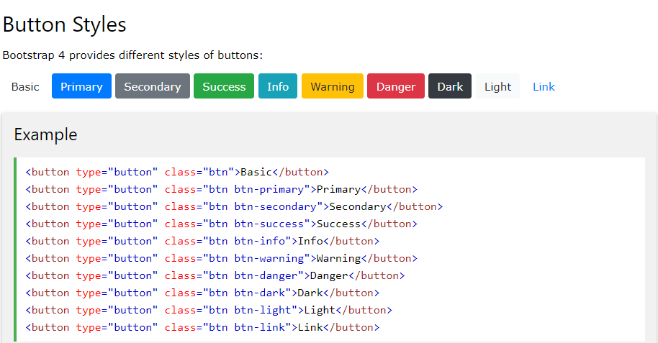

***HTML:***

<a href=" "><button type="button" class="btn btn-primary">NEXT PAGE</button></a>

***CSS:*** *//* THIS CODE IS TO ALIGN THE BUTTON CENTER

.btn{

margin-left:auto;

margin-right:auto;display:block;

margin-bottom:50px;

margin-top:50px;

}

Classes for different colours in buttons:

btn btn-primary

btn btn-secondary

btn btn-success

btn btn-info

btn btn-warning

btn btn-danger

btn btn-dark

btn btn-light

2-OUTLINE BUTTONS

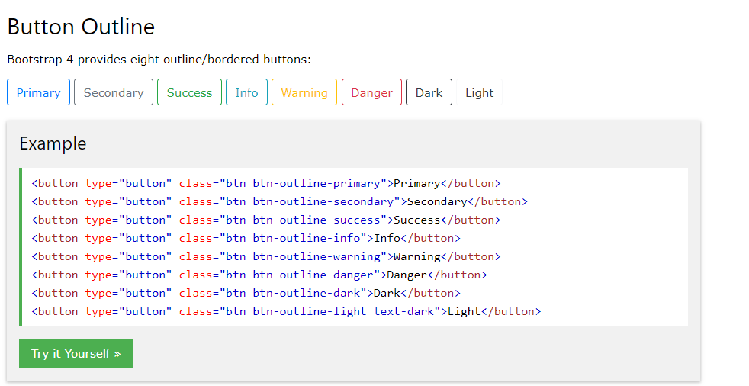

**HTML:**

<a href=" "><button type="button" class="btn btn-outline-primary">NEXT PAGE</button>

</a>

***CSS:*** *//* THIS CODE IS TO ALIGN THE BUTTON CENTER

.btn{

margin-left:auto;

margin-right:auto;display:block;

margin-bottom:50px;

margin-top:50px;

}

Classes for different colours in buttons:

btn btn-outline-primary

btn btn-outline-secondary

btn btn-outline-success

btn btn-outline-info

btn btn-outline-warning

btn btn-outline-danger

btn btn-outline-dark

btn btn-outline-light

FOOTER MODULES

1.SPIDERMAN THEME

|  |  |
| --- | --- |
|  | |
| HTML | CSS |
| <div class="container-fluid footer">  <div class="row">  <div class="col-md-3">  </div>  <div class="col-md-6 text-center">  <h3>Function Book</h3>  <p>At our core is a collectin of design and development solutions that represent  everything you business needs to compete in te modern marketplace.</p>  <strong>Our Location</strong>  <p>100 Street Name<br>Our City, AA 1000</p>  <strong>Contact Info</strong>  <p>(888) 888-8888 <br>email@nest.com </p>  </div>      </div><!--End row-->  </div><!--End of the container fluid section--> | .footer{  background-image: url("images/spider.png");  color:white;  } |

2.IRONMAN THEME

|  |  |
| --- | --- |
|  | |
| HTML | CSS |
| <div class="container-fluid footer">  <div class="row">  <div class="col-md-3">  </div>  <div class="col-md-6 text-center">  <h3>Function Book</h3>  <p>At our core is a collectin of design and development solutions that represent  everything you business needs to compete in te modern marketplace.</p>  <strong>Our Location</strong>  <p>100 Street Name<br>Our City, AA 1000</p>  <strong>Contact Info</strong>  <p>(888) 888-8888 <br>email@nest.com </p>  </div>      </div><!--End row-->  </div><!--End of the container fluid section--> | .footer{  background-image: url("images/ironman.jpg");  color:white;  } |

3.SPIDER THEME WITH COPYRIGHT

|  |  |
| --- | --- |
|  | |
| HTML | CSS |
| <footer>  <div class="row justify-content-center">    <div class="col-md-6 text-center">  <h3>Function Book</h3>  <p> At our core is a collection of design and development solutions  that represent everything your business needs to complete in the modern market place.</p>  <strong>Contact Info</strong>  <p>(888) 888-888<br> email@RPLTECHNO.com </p><hr >  <h5>  &copy;RPLTechno IT SERVICES PVT LTD.  </h5>  </div>  </div>  </footer> | footer{  background-image: url("images/spider.png");  color: white;  padding: 2rem 0 2rem;  margin-top: 1rem;  }  footer img{  height: 3rem;  margin: 1.5rem 0;  }  footer a{  color:white;  } |

4.BARBIE THEME WITH COPYRIGHT

|  |  |
| --- | --- |
|  | |
| HTML | CSS |
| <footer>  <div class="row justify-content-center">    <div class="col-md-6 text-center">  <h3>Function Book</h3>  <p> At our core is a collection of design and development solutions  that represent everything your business needs to complete in the modern market place.</p>  <strong>Contact Info</strong>  <p>(888) 888-888<br> email@RPLTECHNO.com </p><hr >  <h5>  &copy;RPLTechno IT SERVICES PVT LTD.  </h5>  </div>  </div>  </footer> | footer{  background-image: url("images/barbie.jpg");  color: white;  padding: 2rem 0 2rem;  margin-top: 1rem;  }  footer img{  height: 3rem;  margin: 1.5rem 0;  }  footer a{  color:white;  } |

5.KABALI THEME WITH COPYRIGHT

|  |  |
| --- | --- |
|  | |
| HTML | CSS |
| <footer>  <div class="row justify-content-center">    <div class="col-md-6 text-center">  <h3>Function Book</h3>  <p> At our core is a collection of design and development solutions  that represent everything your business needs to complete in the modern market place.</p>  <strong>Contact Info</strong>  <p>(888) 888-888<br> email@RPLTECHNO.com </p><hr >  <h5>  &copy;RPLTechno IT SERVICES PVT LTD.  </h5>  </div>  </div>  </footer> | footer{  background-image: url("images/kabali.jpg");  color: white;  padding: 2rem 0 2rem;  margin-top: 1rem;  }  footer img{  height: 3rem;  margin: 1.5rem 0;  }  footer a{  color:white;  } |